May the God of hope fill you
with all joy and peace in believing, so that you may abound in hope
by the power of the Holy Spirit.
~Romans 15:13
December 15, 2020
Dear Northern Great Lakes Synod,
Since the year 2020 was certainly not a year of clear vision, one can only hope that we will glean what can be learned from it in hindsight. I would guess that I am not alone in my relief to put 2020 in the rearview mirror, but the challenges and disruption that have marked this year will no doubt stretch into 2021.
Before we leave 2020 behind us, I wish to express my sincere gratitude and appreciation for how we have faced this year together. I am grateful for the many creative ways that pastors, leaders, and congregations have risen to the challenge of offering online worship, devotions, events, and activities. Many of you learned new skills in order to stay connected. You made phone calls, sent encouraging notes, and mailed worship resources. We learned how to use ZOOM, FM transmitters, and Facebook Live. We learned how to make masks, give offerings electronically, have Zoom Council meetings, and put protocols in place to keep each other safe. Together, we pivoted, adapted, shifted gears, and shifted gears again. It has been exhausting, and while I know we are not done with this pandemic yet (and have no idea how it will shape our future), I have to say… Well done!! Excellent!! Keep up the good work!
Continue with patient resilience, and soon enough the pandemic will join the year 2020 in hindsight, and we will regroup, reassess, and reapply ourselves to the work of Christ in a post-pandemic world.
To that end, we turn our faces toward the future with hope.
I think of my Uncle Paul used to work for Lutheran Bible Translators in Africa. He told the story once of going into a village to learn the particular dialect in order to translate the Bible into that language. However, he could not find a local word for “hope”… until that is, he heard the story of a boy whose father worked for weeks at a time away where the jobs were. And the boy would wait under the shade of a tree at the edge of the village to watch for his father to come down the road. The word, “hope” then was translated as “watching for you to come down the road.”
With hope we watch for all that is coming down the road. We watch for Jesus to come to us. We watch for how we will be new and different as church to become clear. We wait for an end to all that has made us weary this last year, and we watch for a return of so much that we have missed about congregational life. We hope, we watch, and we wait.
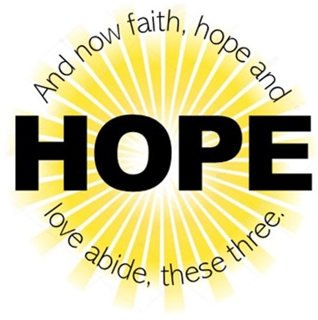
I hope the challenges of this year has given you a deeper conviction of the value of the life of faith. And I pray that you will be filled with the peace that only hope born of Christ can give.
May God bless us with faith, hope, and love in the Year of our Lord 2021,
but mostly
with hope.

Yours in Christ,
Bishop Katherine Finegan

